Report

Laboratory Work 1

Dmitry Ladutsko

August 24, 2022

# 

# 1. Lab 1: Introduction to SQL Server Integration Services

## 1.1. Exercise 1: Using the Import and Export Wizard Scenario

The Marketing department at Adventure Works requires a current list of the currencies used in the AdventureWorks2012 database. They want the list in the format of a comma-delimited text file. You must use SQL Server Integration Services to provide this information in the correct format and create the flat file from the information in the currency table (Sales.Currency). The name of the output file must be Currency.txt and it must contain the following fields: CurrencyCode, CurrencyName. You have to use Import and Export Wizard and save automatically created package within the solution.

***Note.*** Firstly, I Downloaded SQL Server, SQL Server Management Studio, Visual Studio and SQL Server Integration Services. Used SQL Server to import dump database (AdventureWorksDW2019.bak)

***Note.*** Then I created project and connection.

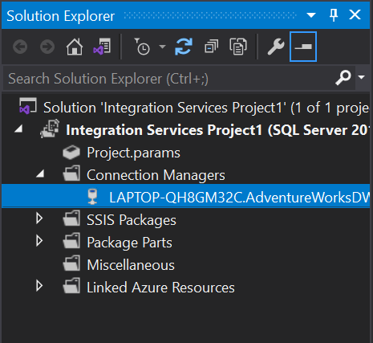

***Note.*** Now let’s create a new package to load data from AdventureWorksDW2019.bak into CSV (Currency.txt)

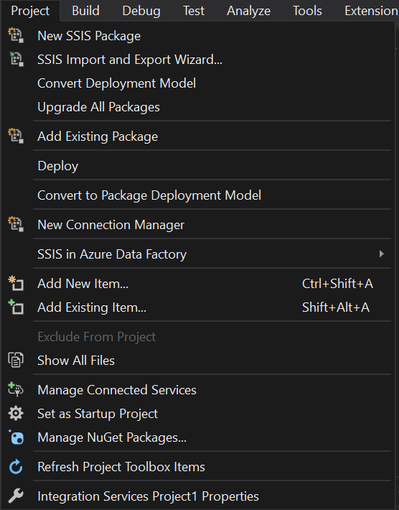

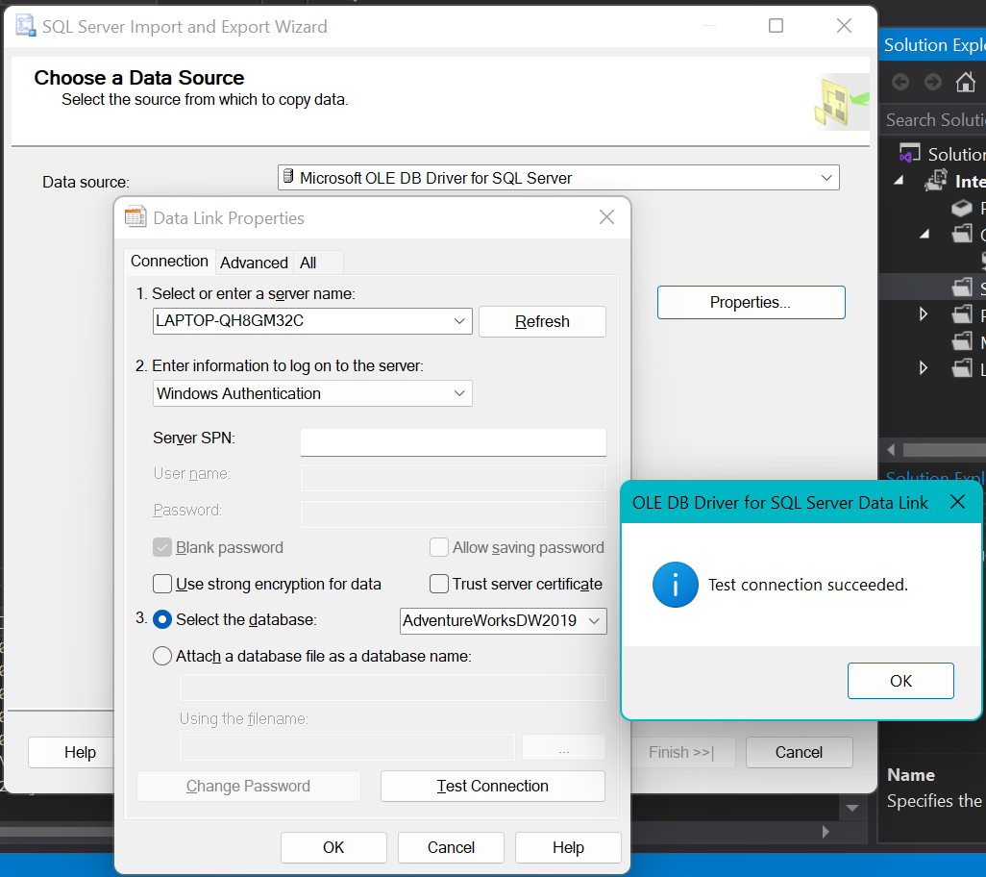

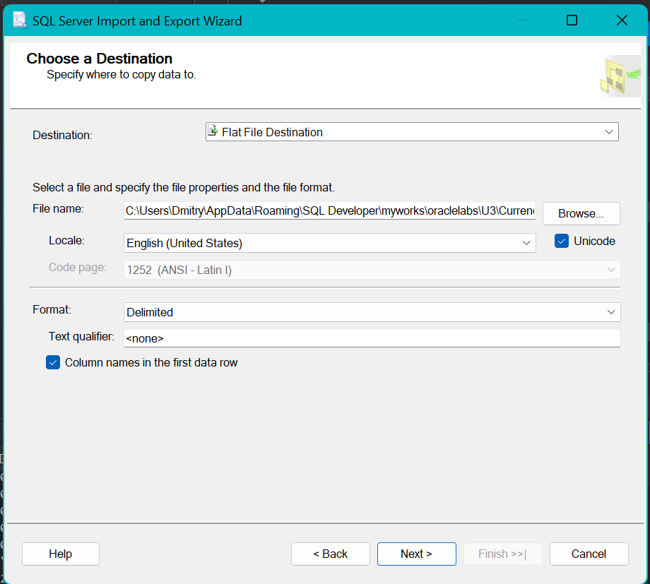

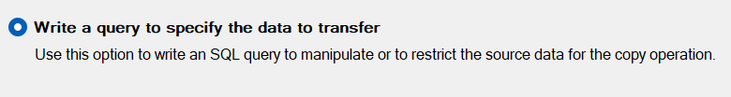

***Note.*** I chouse Write a query to select only columns specified in task (CurrencyCode, CurrencyName).

select [CurrencyAlternateKey],[CurrencyName]

from [dbo].[DimCurrency]

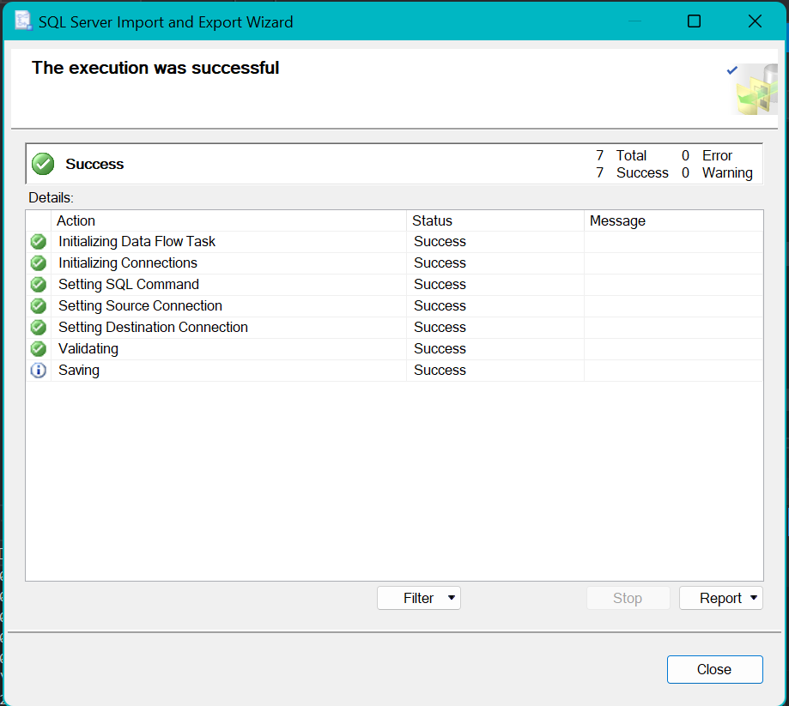

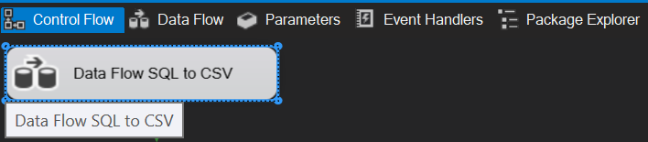

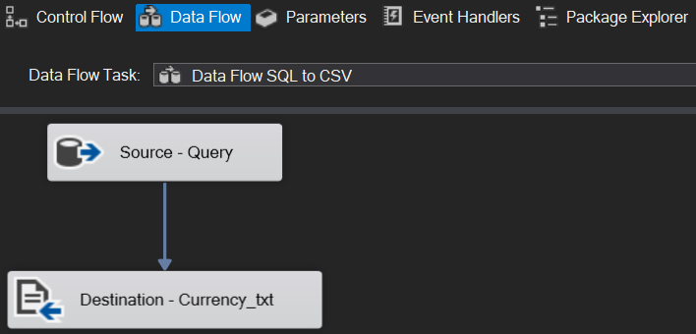

**Result:** Screenshots that shows using Import and Export Wizard.

## 1.2. Exercise 2: Running an Integration Services Package

Now that the package is created, you will execute it and complete the export.

In this exercise you will run the CurrencyExport package and confirm that the export completed successfully.

You should execute the package from Visual Studio.

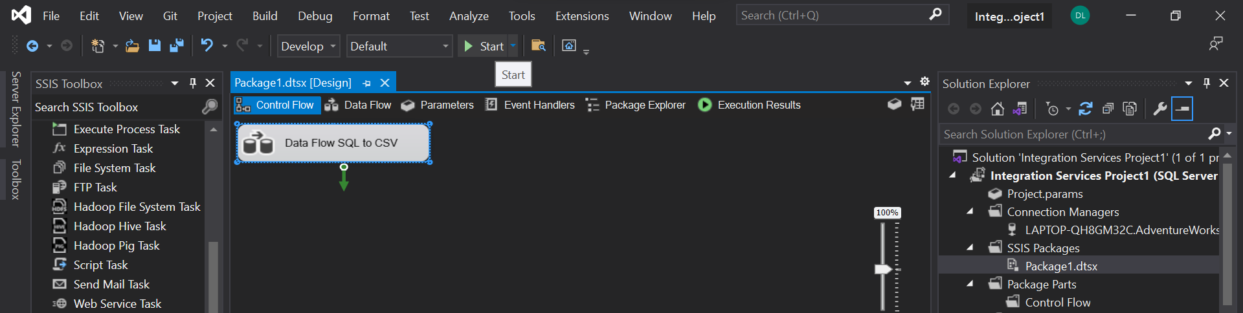

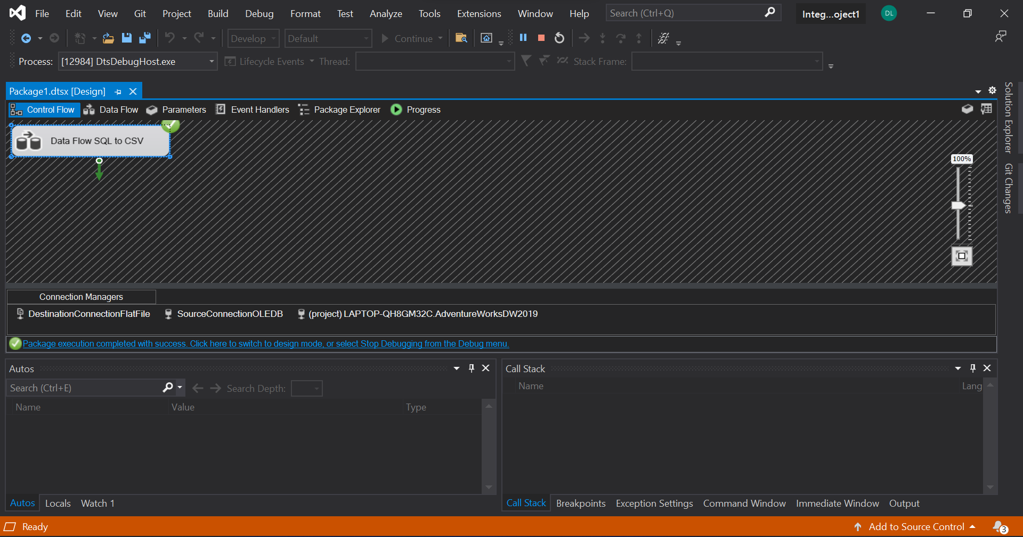

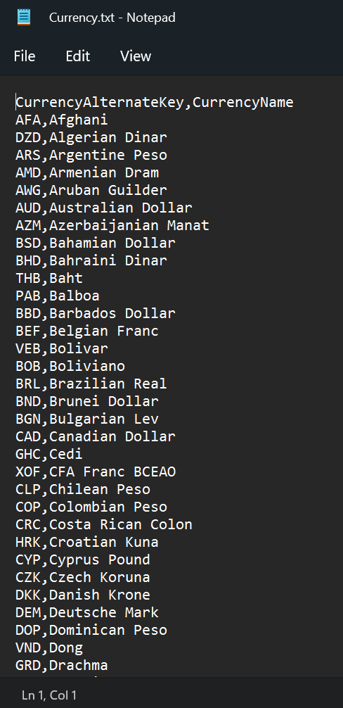

***Note.*** Also imported report in file to practice how it works*

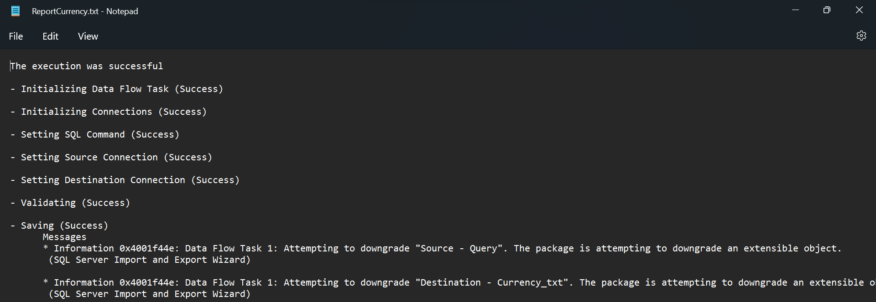

***Note.*** Here is same query from SQL Server AdventureWorksDW2019. [dbo].[DimCurrency]

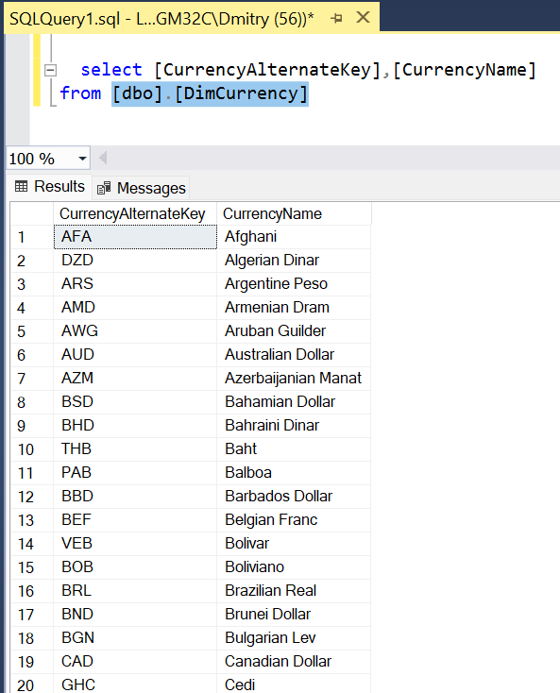

**Result:** Output file that contains the list of currencies

## 1.3. Exercise 3: Import Data Using the Import and Export Wizard

Use the Import and Export Wizard to import data from the flat file (Currency.txt) to the SQL database.

In this exercise you will use the Import and Export Wizard to move data stored in a flat file to the SQL database.

The file should be imported to a new table that will be automatically created by the wizard.

***Note.*** Let’s now transform this CSV into new table in SQL Server

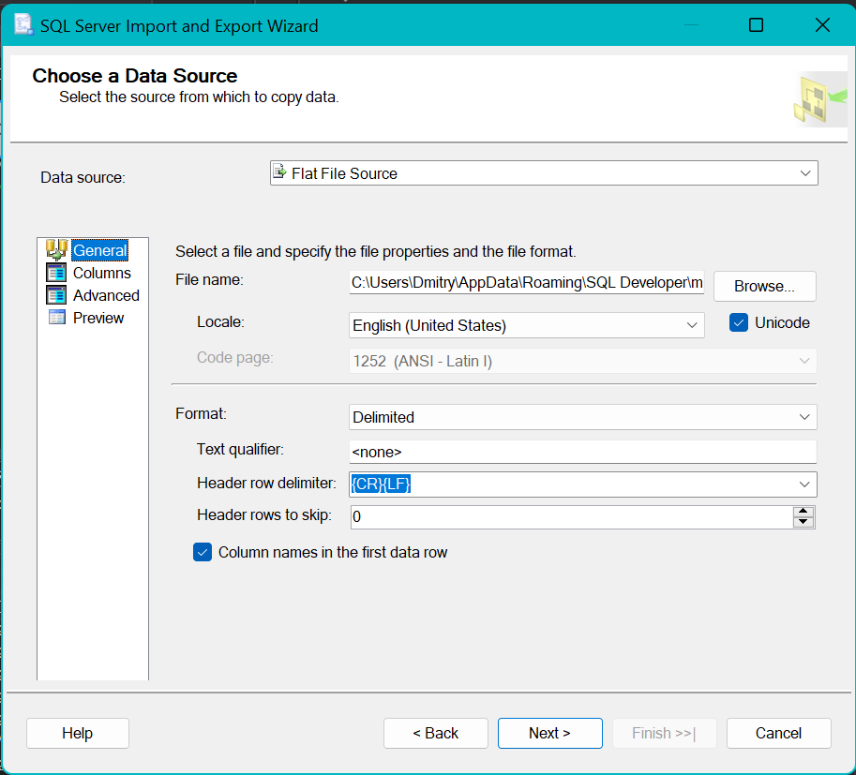

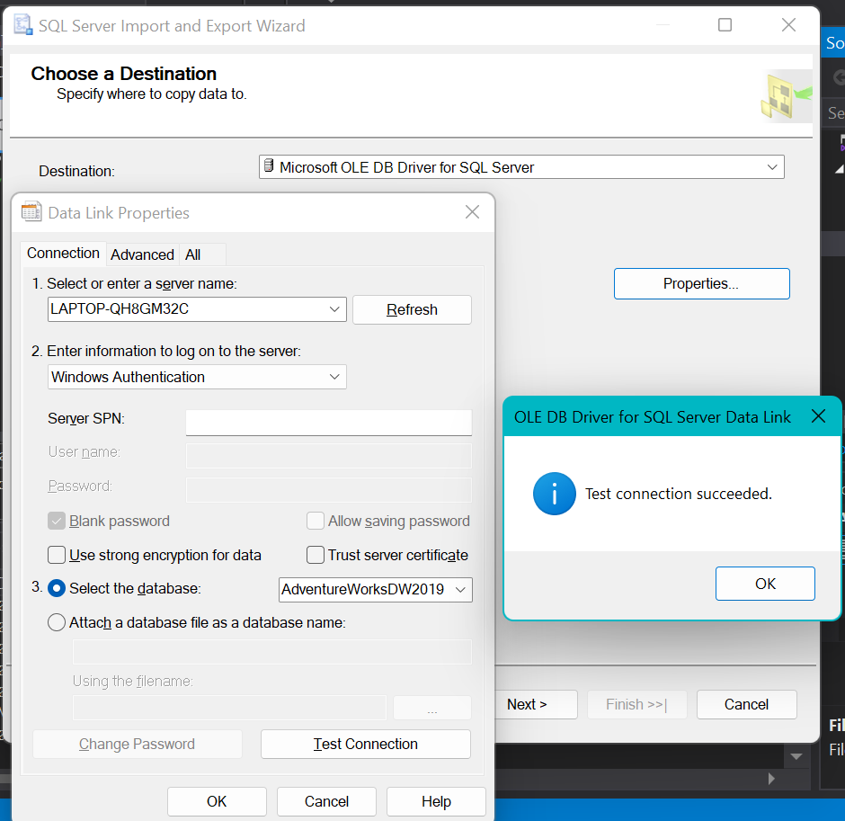

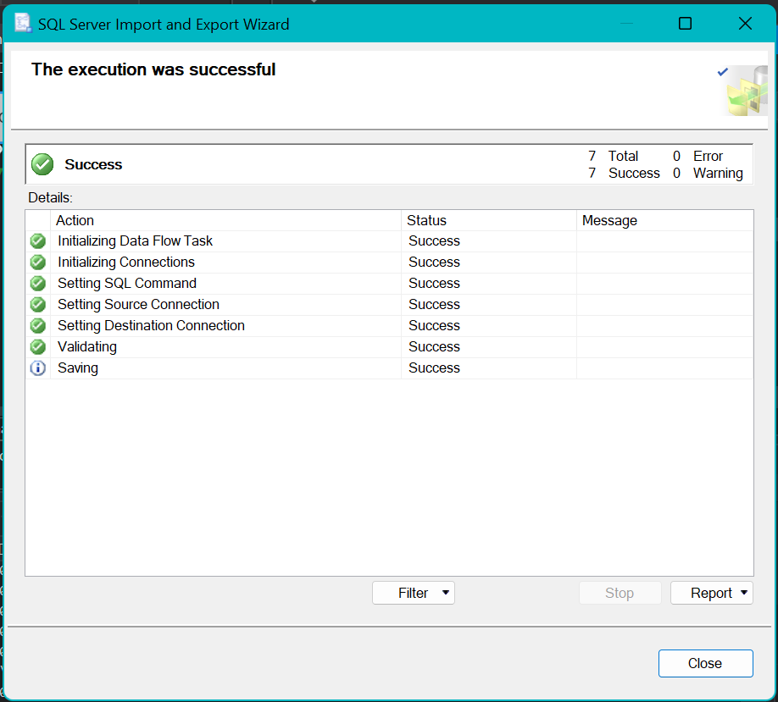

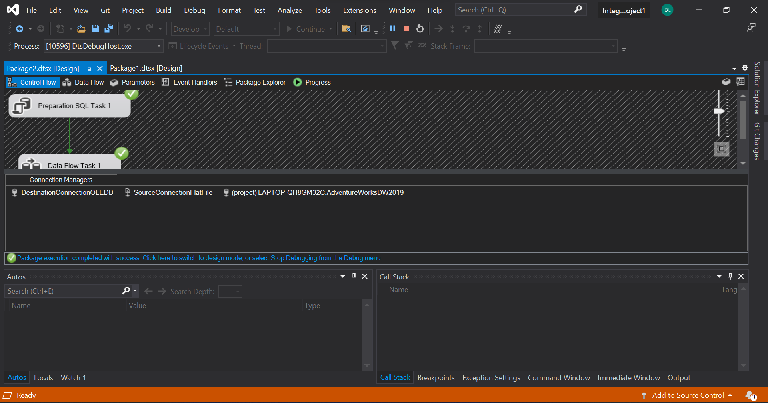

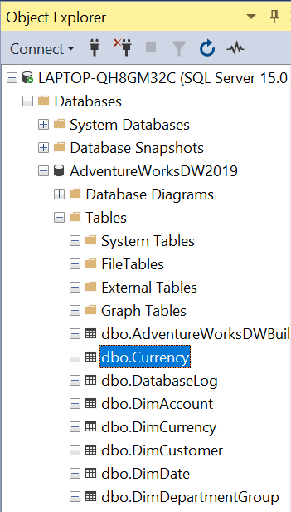

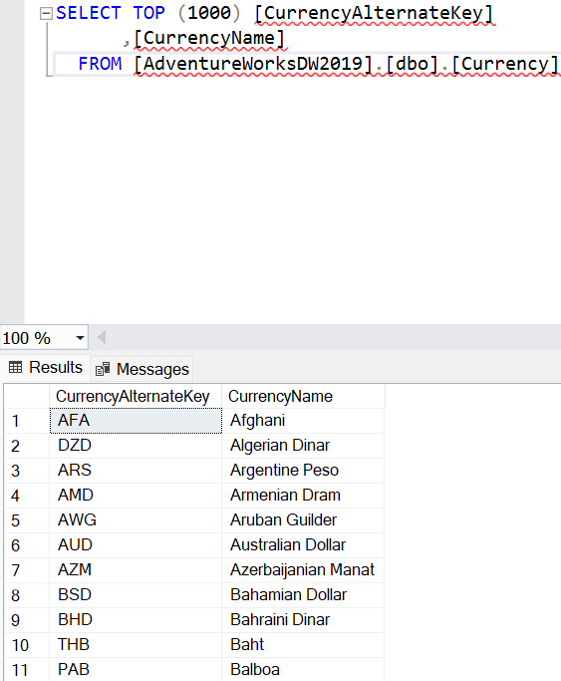

**Result:** Screenshots that shows using Import and Export Wizard.

**Laboratory Work Summary**

**At this Laboratory Work** we were introduced with such new services and programs as SQL Server, Visual Studio and SQL Server Integration Services.

**Practiced** how we could **transform** data in (from) different object types, creating **connections** and **packages**, working with **data flows.**